

USER MANUAL FOR

INTESTATE SUCCESSION PARTITION

GOVERNMENT OF ANDHRA PRADESH

REGISTRATION AND STAMPS DEPARTMENT VIJAYAWADA
2025
- Enter APIGRS website
- Select Document Entry & Registration Service

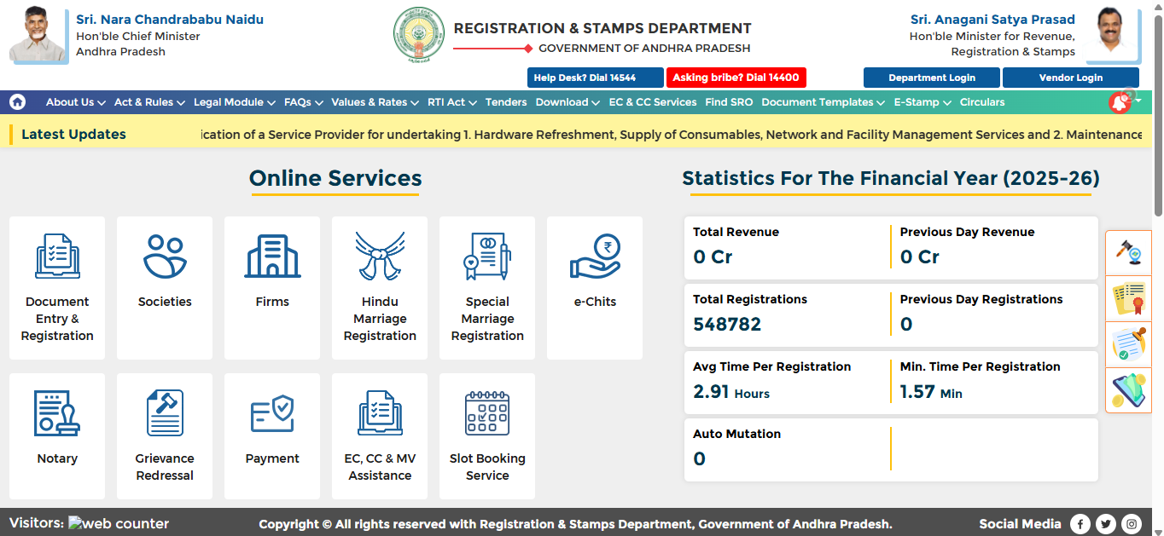
- Upon selecting the user directed to Card PRIMME (PDE application) in the New page.
- Now User login into PDE application either with Mobile or Aadhaar or Email ID
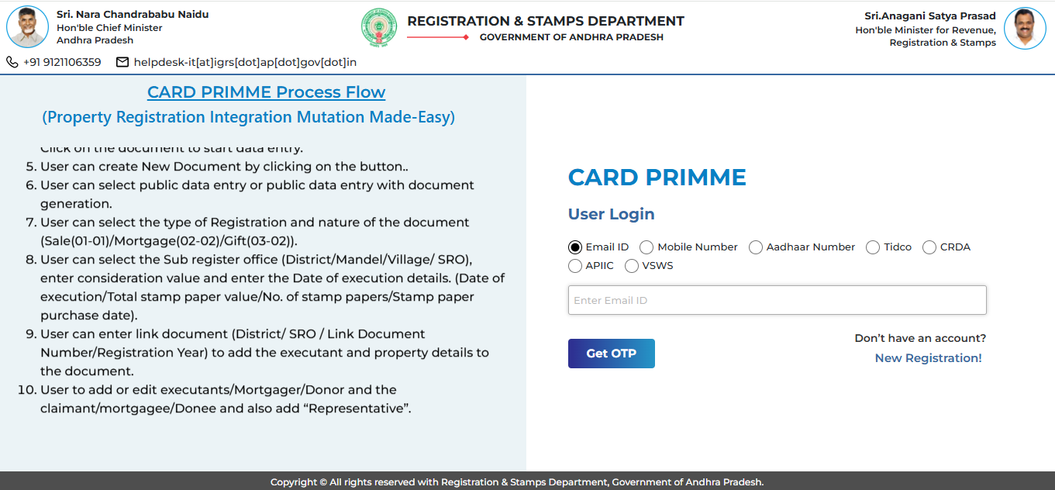
- After Successful login to the PDE application, the user needs to select PUBLIC DATA ENTRY service
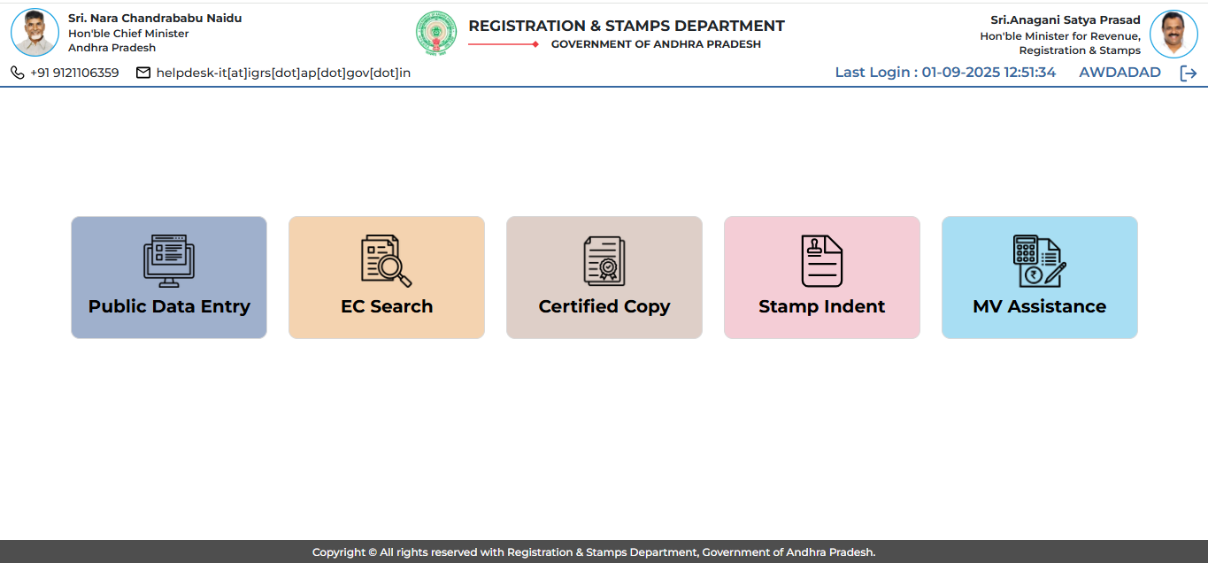

- Clicking on Public Data entry, the user is directed to Next page where several services for registration process are display
- Now click on Create Document option
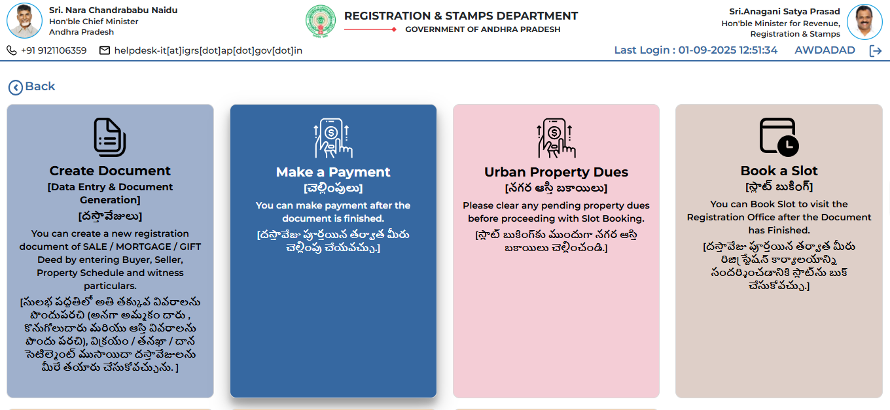

- System directs the user to New Document creation page where Lists of already created applications are displayed along with the New Document creation link

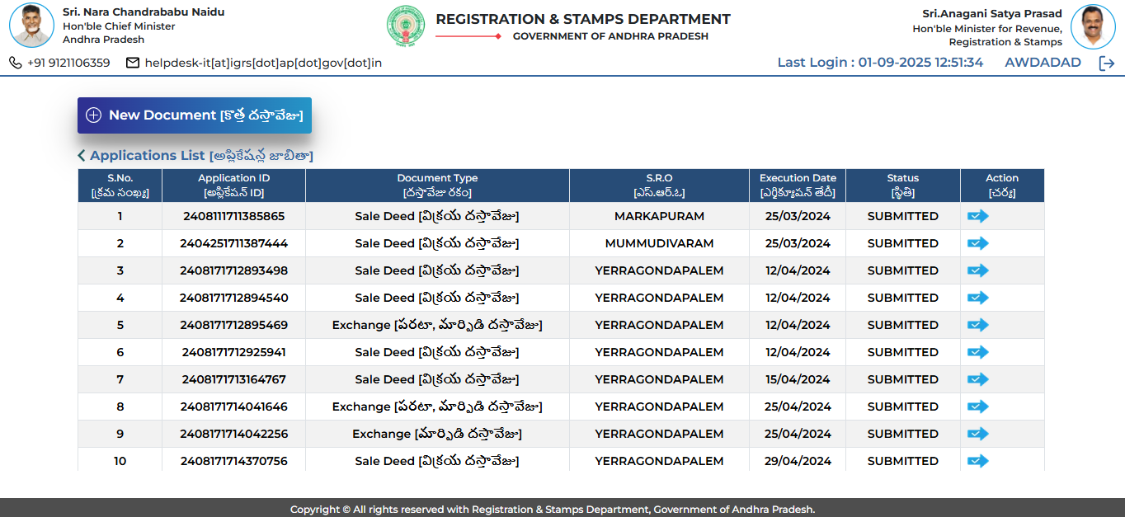
- Now User directed to Get started Page
- Select Type of Registration as ‘Partition”
- Upon selecting Partition- System display New classification “Intestate Succession Partition” under Nature of Document dropdown
- Select Intestate Succession Partition and entered all mandatory fields like
Register office selection, Total Consideration value, Date of Execution details etc.
- User can also enter Link Document details ( If Applicable )
- After entering all details in the Get started Page, Click on Proceed button
- Now System create new application ID and user directed to Parties Details page

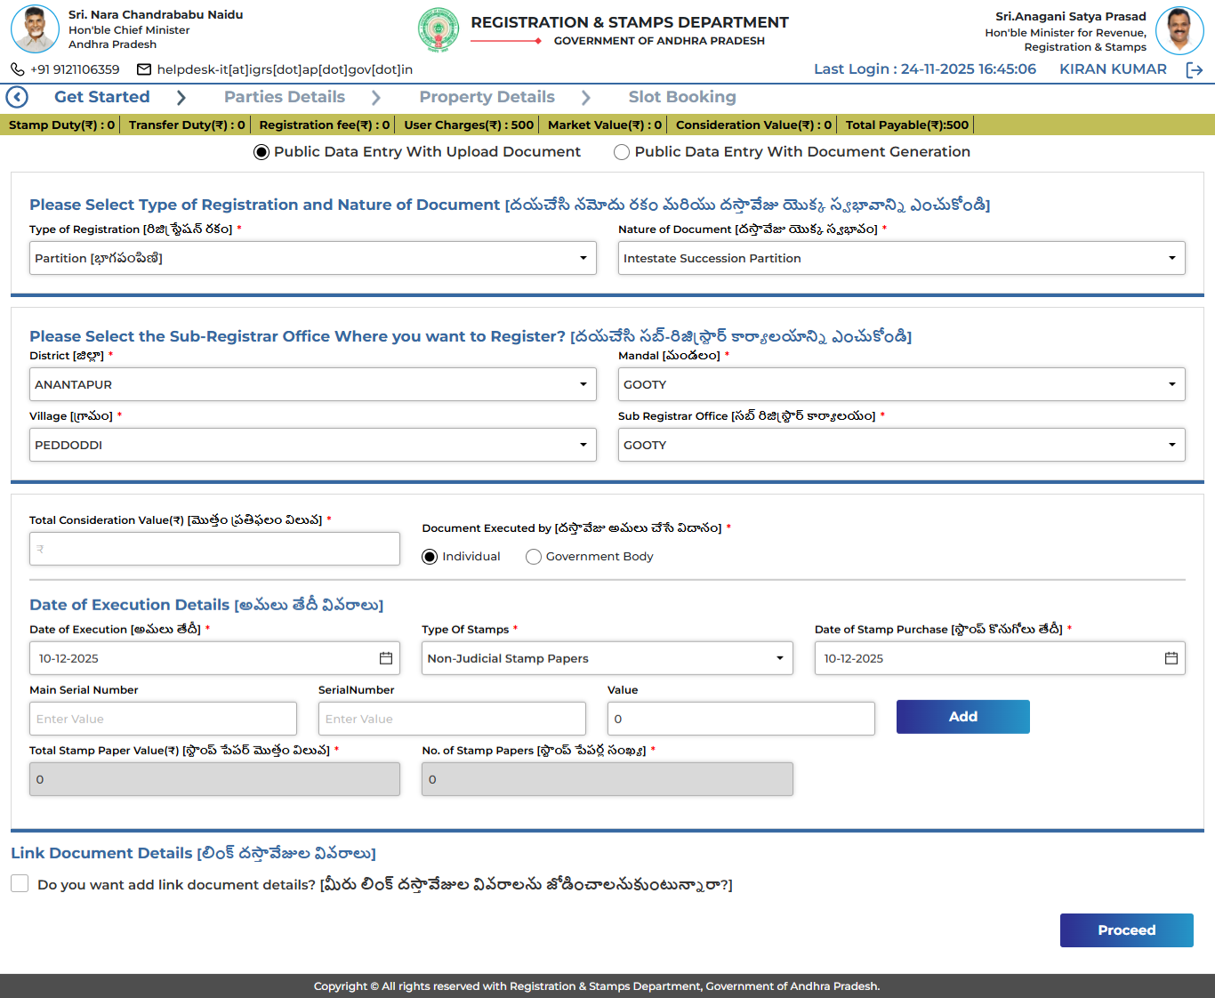

- Click on Add Claimant - add parties to the Intestate Succession Partition application

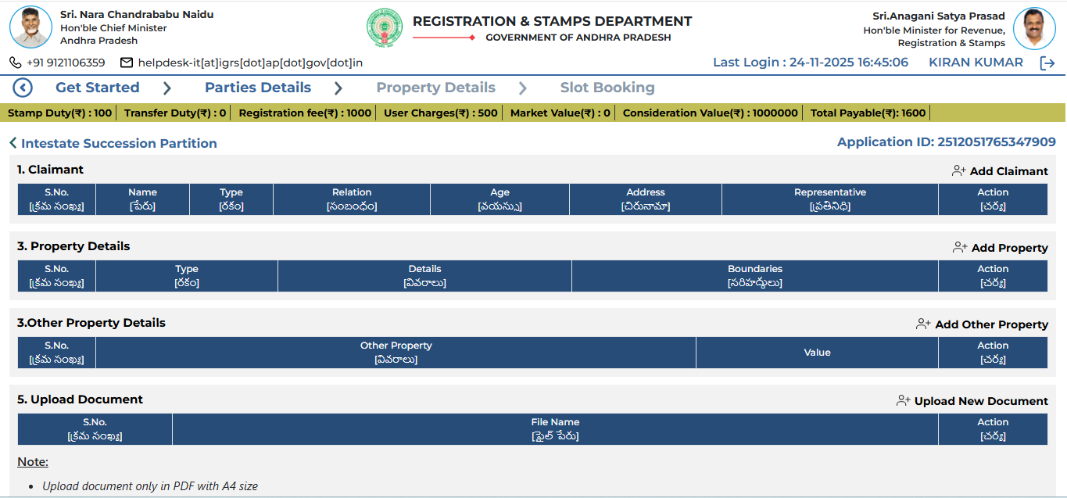
- Claimant can be any type of Party details as shown below
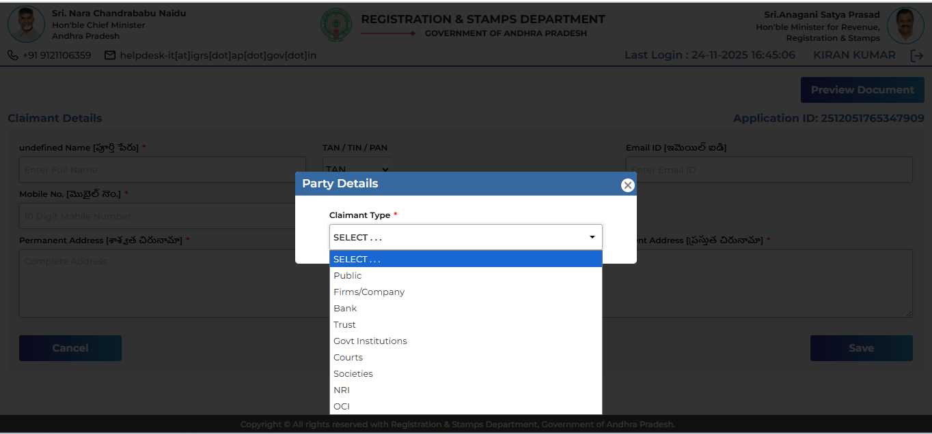
- User can Add Claimants – With Aadhaar OTP or Without Aadhaar OTP
- After adding Claimants – Claimants details are shown in the claimant table as shown below

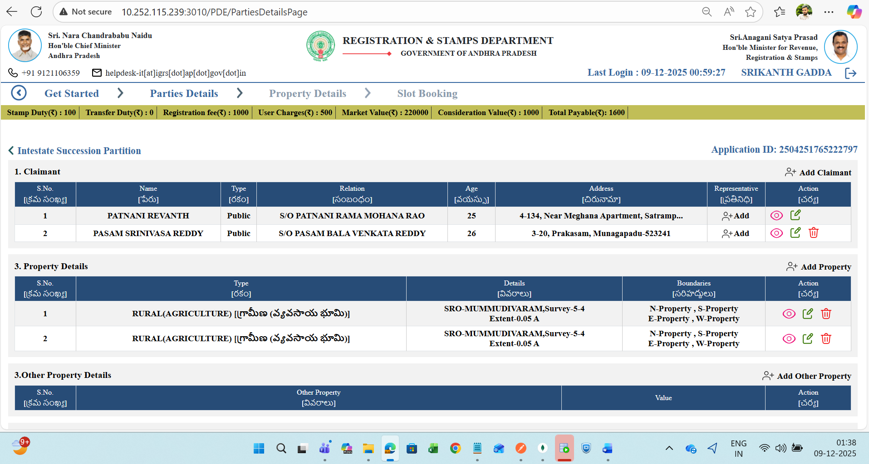
- User can also add a representative to the Claimant ( if Applicable)
- Upon Adding Representative, the details are displayed under specific claimant

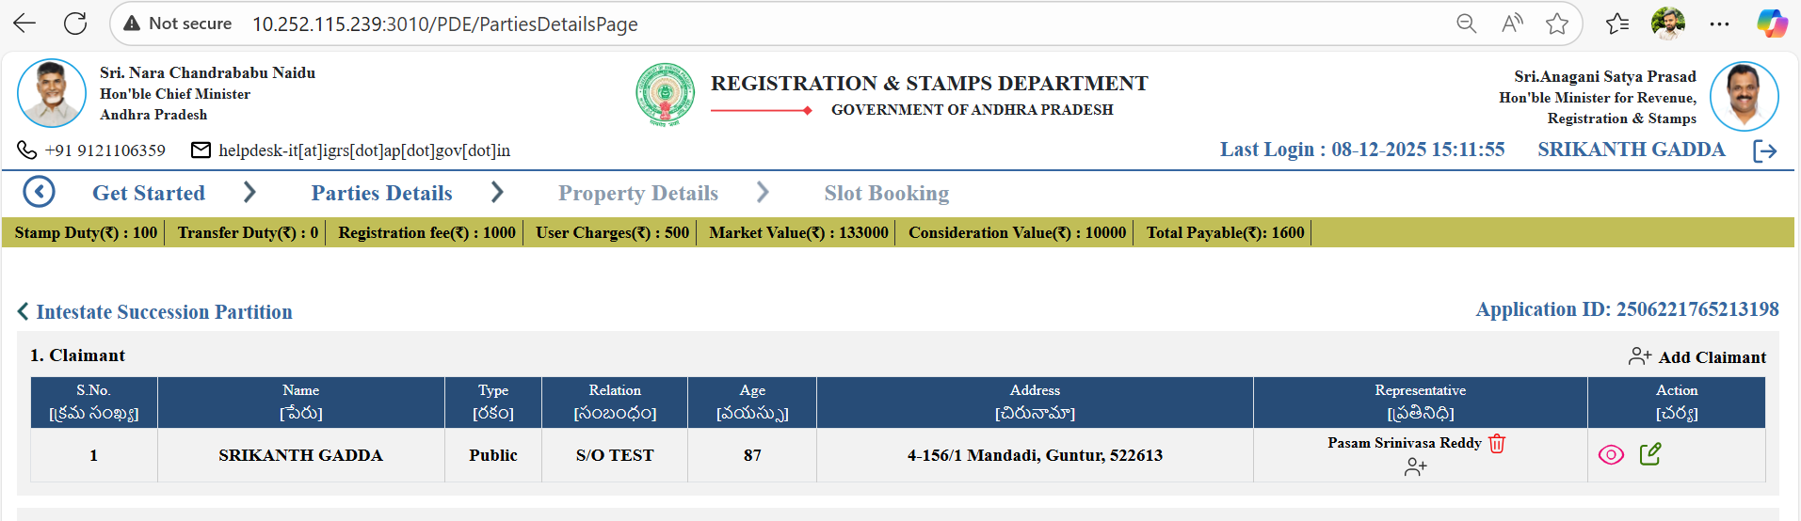

- For Intestate Succession Partition – Minimum two claimants are mandatory, adding one claimant and moving to further display – error message as shown below
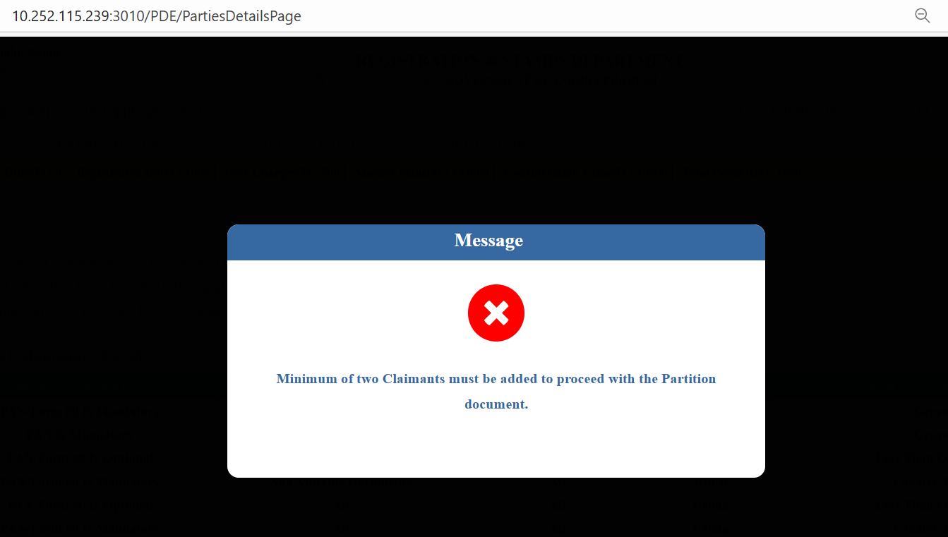

- After successfully adding the claimants & representatives for the Intestate Succession Partition documents, the next step is to add Property
- Now the user clicks on Add Property
- Enter Property Jurisdiction SRO details
(User can avail Anywhere documents case also if applicable)
- Now system display only Rural – Type of Property options
- User can select Rural properties only
- Upon selecting Rural properties type, user can select Land Use type and other options as shown below

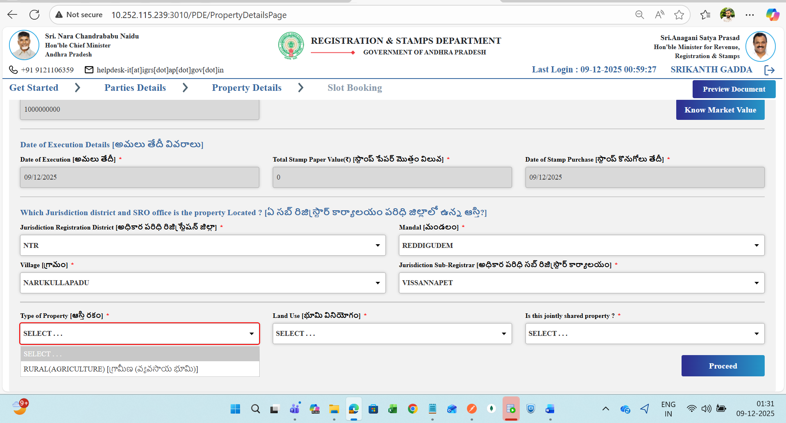

- User can select either Survey or LPM based village
- Adding Schedules less than Occupant extent, restrict the user by showing error

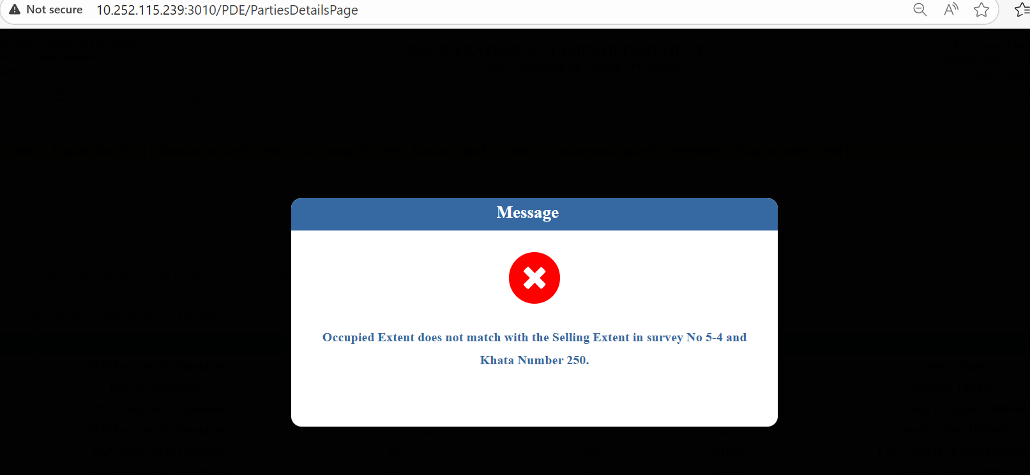
- After adding Multiple schedules – by matching the Selling extent with the Occupant extent value, Market value is displayed
- user can add Multiple schedules with Same survey number
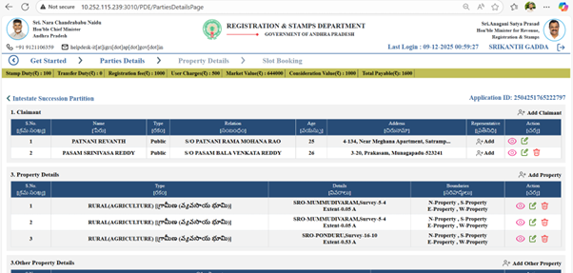
- Observe the Duty fee calculation is calculated based on Higher value between Market value or Consideration value and display in the banner as below charges
DSD:
- ₹100 if market/consideration value ≤ ₹10 lakhs
- ₹1000 if market/consideration value > ₹10 lakhs
RF: ₹1000
User charger: ₹500

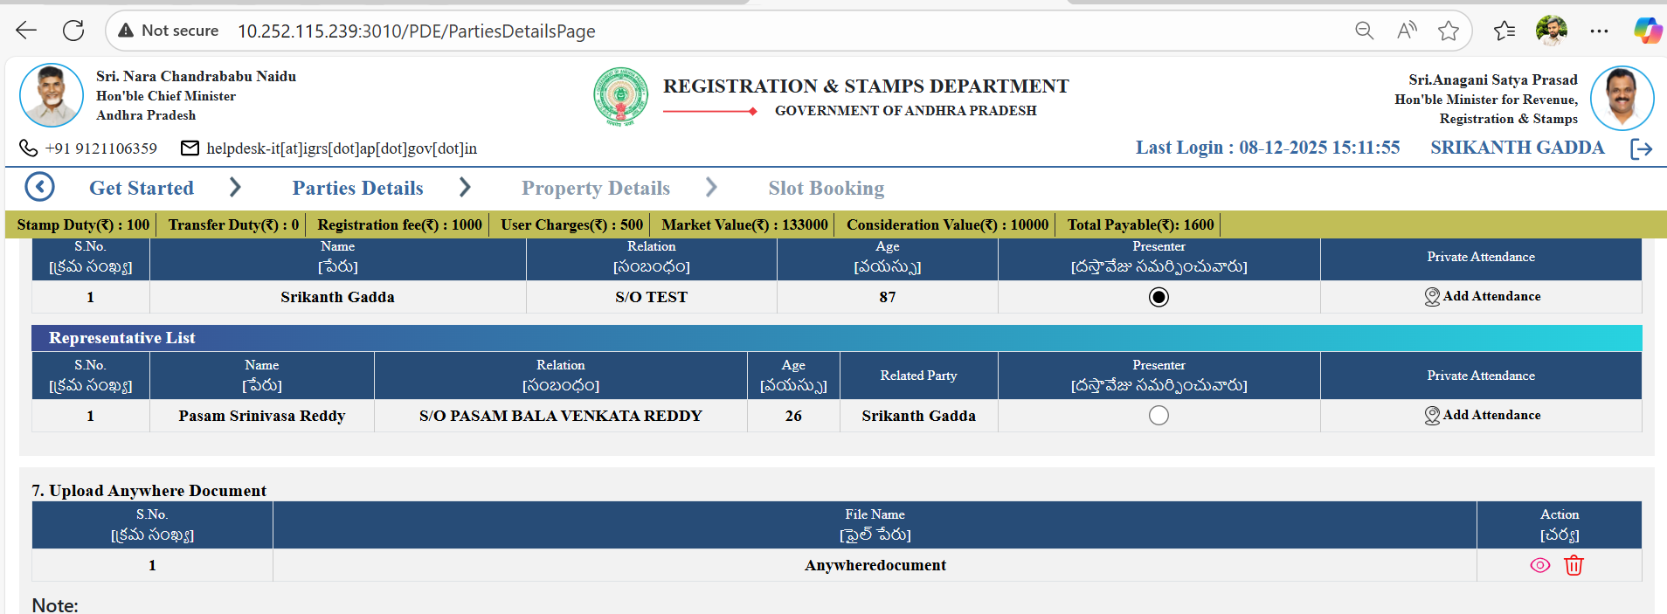
- If the user create the Intestate Succession Partition Documents in Anywhere cases, the user need to add Anywhere Document, or else system display error message

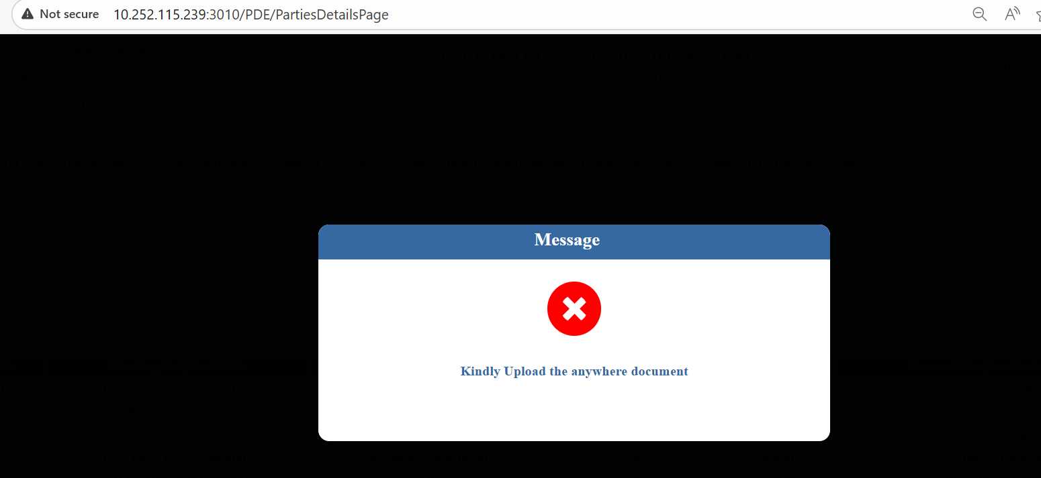
- After Adding Parties details, Property details etc, User need to upload 3 mandatory documents- Death Certificate, Family member certificate, Mutation Application ( Available at the APIGRS website under the Download Menu)

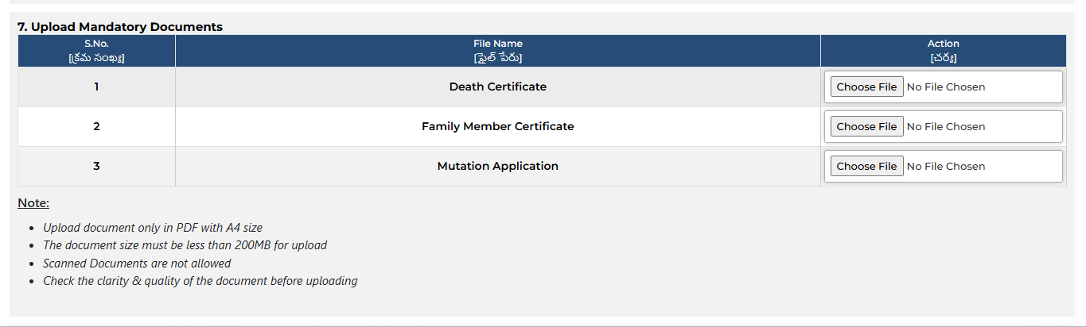
- Now select Presenter and Click on Final Submit, System display Successful message

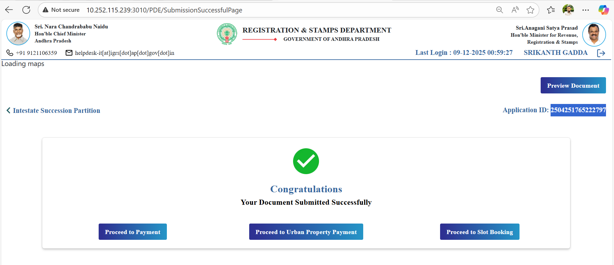
- Complete Payment Process and Slot booking process

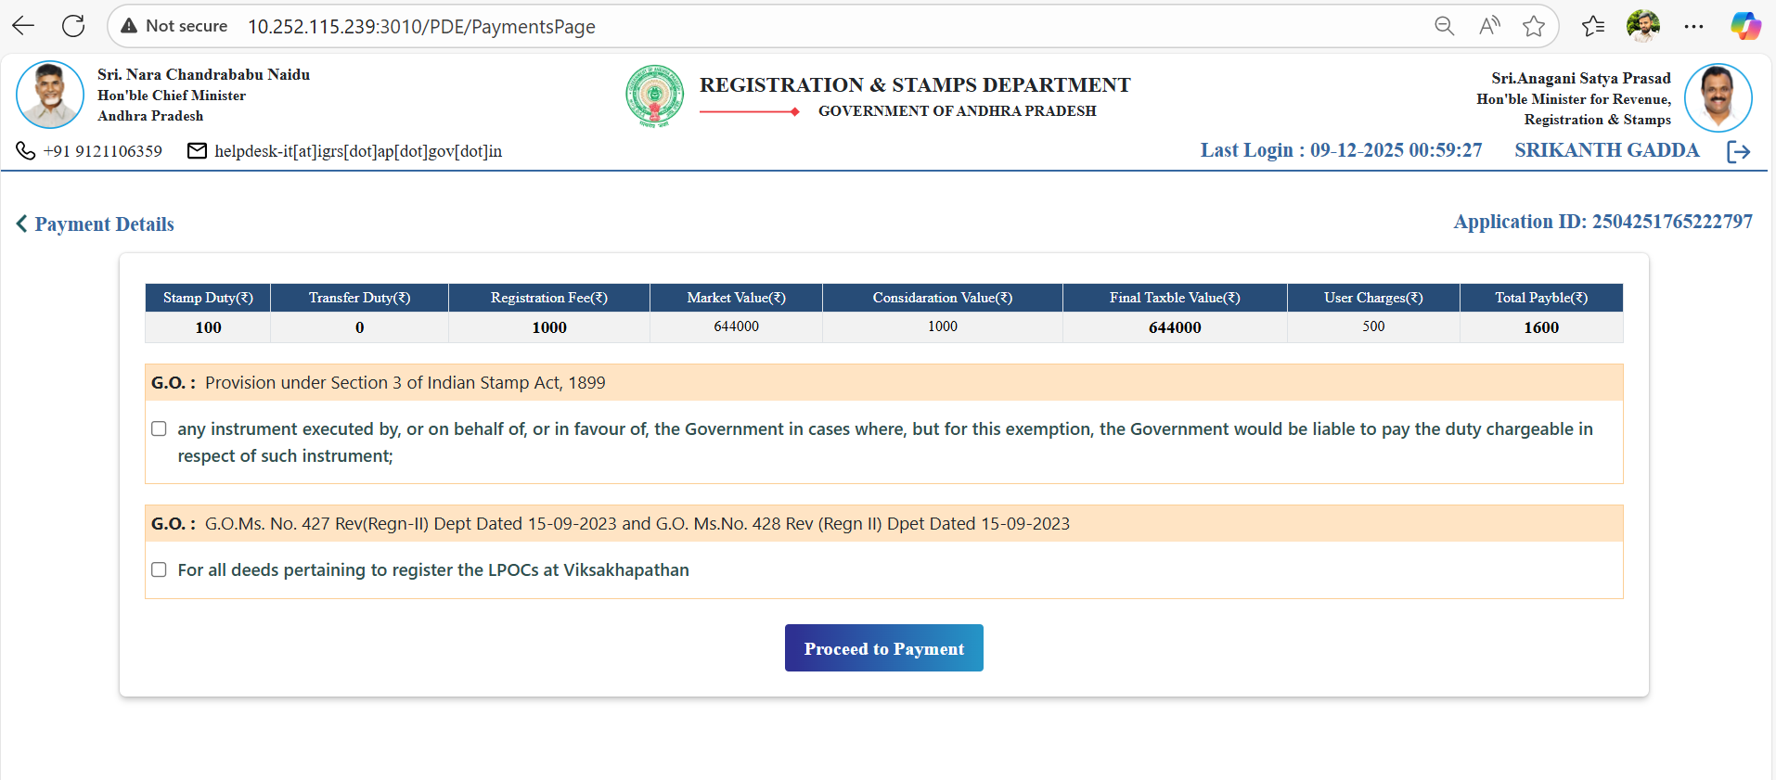

- After booking the Slot for Intestate Succession Partition Document – User journey is completed

Card Side Process:
- Upon submission of Intestate Succession Partition document by Public from PDE, the application is display to the Registered SRO login
- After Completion of Anywhere Authorisation ( if Intestate Succession Partition is Anywhere Document ) or Regular Type of Intestate Succession Partition document the SRO Verify the Document in the Scrutiny page
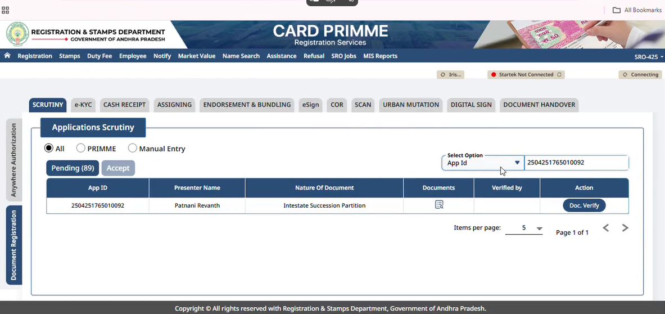
- SRO need to verify the Checkslip along with 3 mandatory documents Death Certificate, Family Certificate and Mutation Application related to Intestate Succession Partition application
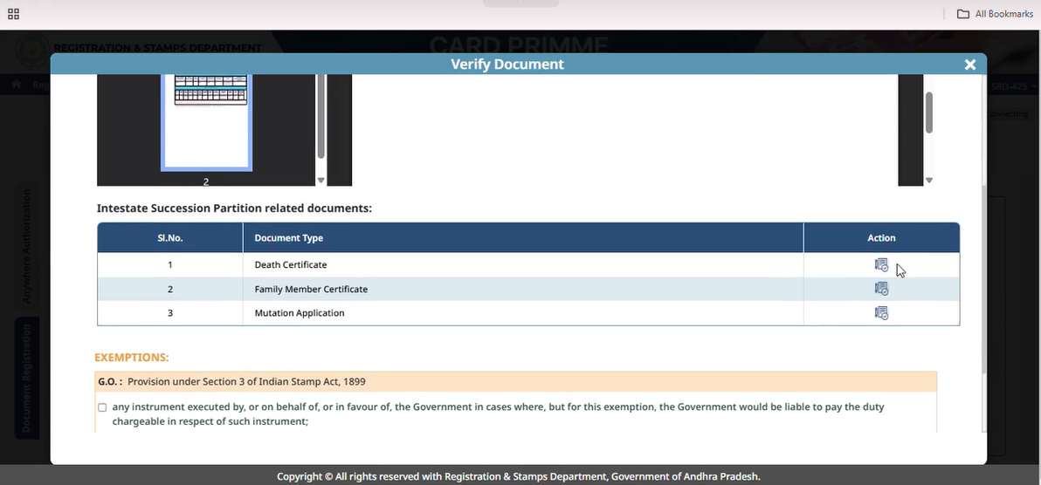
- After Verification, SRO can Generate the CS no.
- Remaining process as usual as regular Rural registration Process

